1. Practice to create and configure client-usernames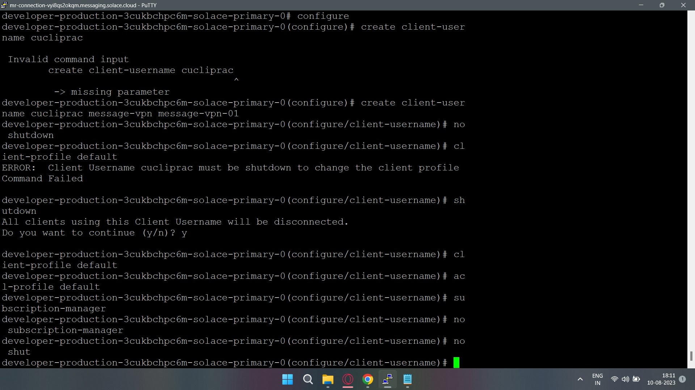
2. Practice ACL client creation + configuration + assigning permissions to different properties [client-connect/publish-topic/subscribe-topic/etc] + Assign the exception list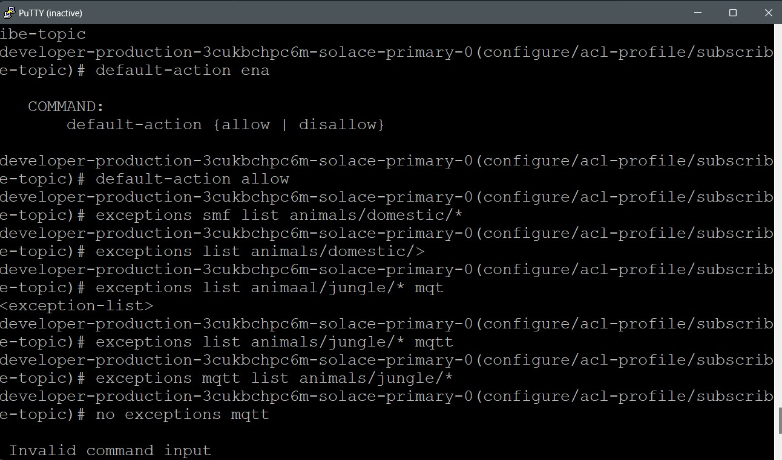
3. ACL Pub/Sub-topics :: Exception list :: MQTT --> SMF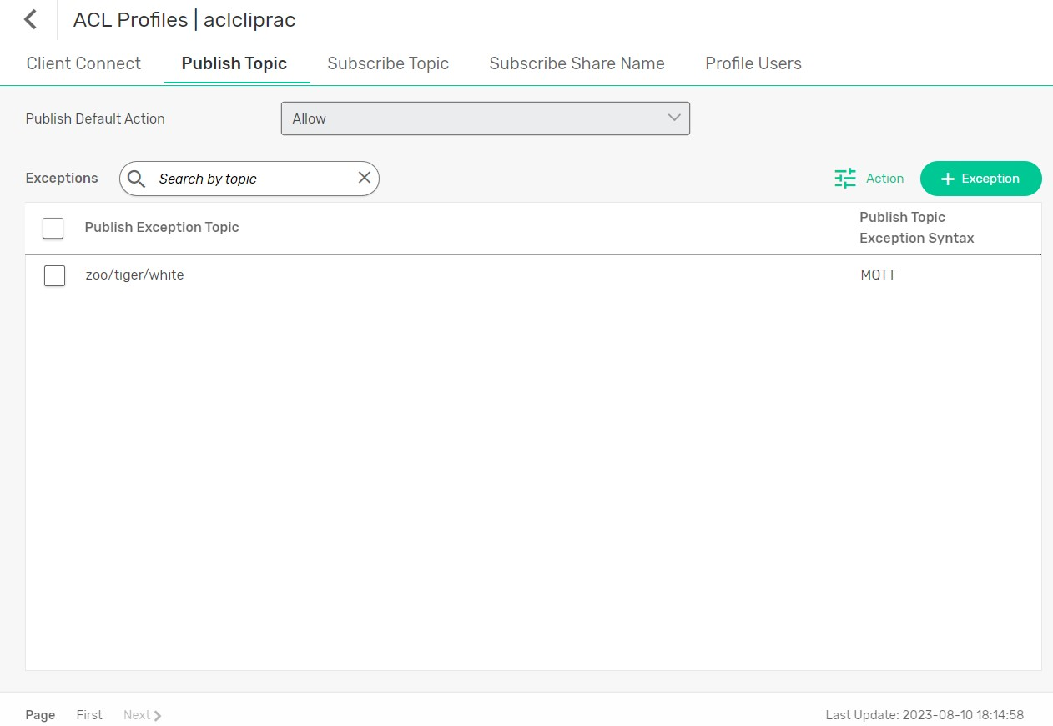
4. How to delete a subscriber-topic exception list of ACL profile using Solace Command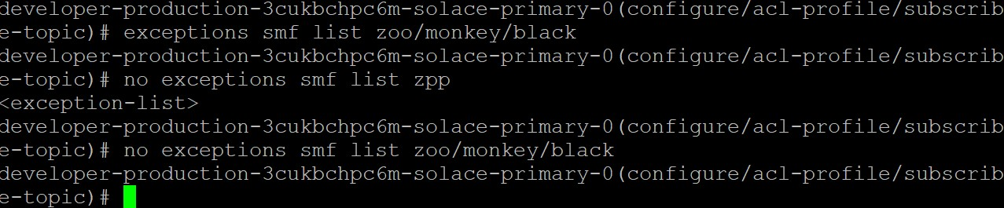
5. Create and configure client-profiles